School Bus Status – App now available for Android
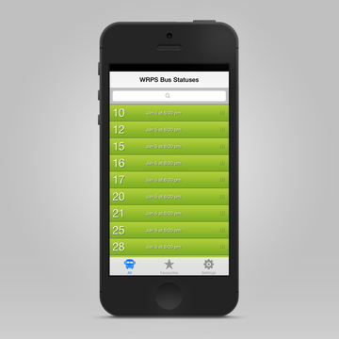
Wetaskiwin Regional Public Schools Bus Status app is now available for free download on android phones at Google Play. The Wetaskiwin Regional Public Schools Bus Status App displays up to date bus information for the Wetaskiwin Regional Public Schools. The app is connected to the school bus status webpage that is featured on the division and school websites. Each time the bus status is updated on the website the app will push a notification to your android phone. The app is provided as a service to parents/guardians of students who ride Wetaskiwin Regional Public School buses. There is a safety element in that parents/guardians will be notified of a cancellation of busing service, or a delay in service.
The app, created by Box Clever, ties directly to school bus status updates posted to the Wetaskiwin Regional Public Schools website, and individual school websites. The app offers a simple, easy-to-browse interface, searchable bus listing, simple pull down to refresh route status, option to share bus status information via text messaging, email or Facebook and Twitter, and the choice to identify specific routes as favorites. Any change to the status of a favorite bus route will result in a push notification on your android phone.
If you’re not sure of your bus route number, you can see the routes listed by driver name on Wetaskiwin Regional Public Schools website once you download the app, you can “favorite” your child’s route by number and receive push notifications should that route be cancelled or delayed.

Offering the same features as the iPhone app, the newly developed Android app will allow both parents and students to receive push notifications for delayed & cancelled buses. With its bold, easy to read and simple design, users will have no problem tracking the bus they need.
You can download the Android App on Google Play or the iPhone App on the Apple App Store.

IPhone School Bus Status version 1.1.1. Update
The iPhone Bus Status iOS app has also been updated. If you have not already done so please update your Bus Status App to receive the new version of our Bus Status iOS App.
Download it from the App Store. Don't forget to update your Bus Status app so you can continue to receive push notifications.

